**TEAM INCOGNITO**

**CHECKERS GAME**

Chirag(20CBS1049)

Mohit(21BCS10085)

Ayush(20BCS3868)

Shruti Sharma(20BCS3639)

Vani Gupta (20BCS4068)

**Tech Specifications:**

**Language: Python**

**IDE:VS CODE**

1. **Class Diagram:**

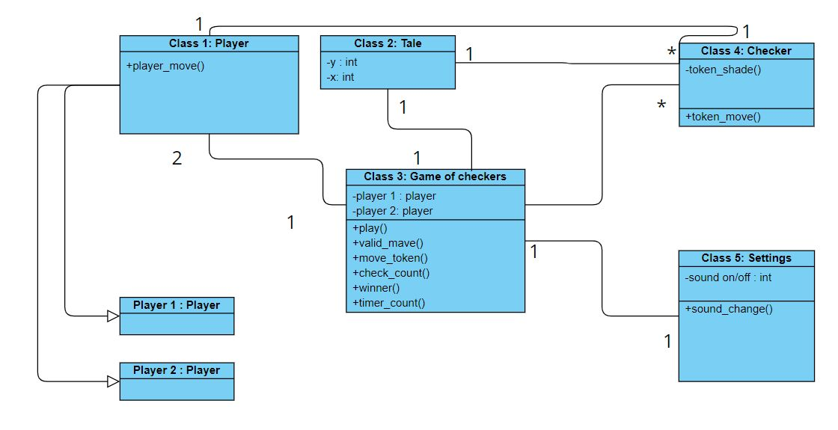

1. **Flowcharts:**

